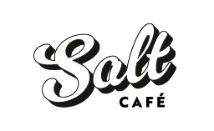

Eggs your way on sourdough toast $12
+$2 for GF bread

Coconut chia pudding with maple hazelnut clusters and summer fruit compote $16

Strawberries and mascarpone cream sourdough crumpets with shortbread crumble $18

Avocado toast with aioli, feta, chilli seeds, fresh herbs and poached egg $19

Tomato and haloumi bruschetta on garlic sourdough $18

Creamy mushrooms on sourdough toast $18

Pulled pork benedict with apple cider hollandaise $22

Open steak sandwich with caramelised onion, blue cheese and rocket $20

Sides:
Bacon, tomato, avocado, mushrooms, haloumi $6.50

Kids Lunchbox – cheese toastie, fruit, brownie $12.00
Kids eggs on toast $10.50

